PROJECT REPORT

# **BY**

|  |  |
| --- | --- |
| **Team ID** | **SWTID1743254297** |
| **Project Name** | **TUNETRAIL- YOUR PATHWAY TO PERFECT PLAYLIST** |

**MEMBERS-**

**KHUSH KEDAWAT -22BCE11095**

**RITIK TIWARI – 22BCE11395**

**AADYAA SUNDRIYAL -22BCE11314**

**PRIYANSHI MAHAJAN -22BCE11037**

**SMARTBRIDGE FULLSTACK EVELOPMENT USING MERN**

**1. INTRODUCTION**

**1.1 Project Overview**

With the rapid evolution of digital technology and increasing internet accessibility, music consumption has significantly shifted from offline downloads to online streaming platforms. This project aims to develop a **Music Streaming Website** that allows users to seamlessly stream, explore, and interact with a large collection of songs across various genres and artists.

The platform is designed to be **user-centric**, offering both free and premium services. Free users can stream music with limited functionality and occasional ads, while premium users enjoy an ad-free experience with added benefits like offline playback and high-definition audio quality.

This system supports two primary user roles:

* **End Users**: Individuals who register on the platform to stream and organize music.
* **Artists/Admins**: Verified users who can upload tracks, view analytics, and manage their music content.

The website is built using the **MERN (MongoDB, Express.js, React.js, Node.js)** stack, enabling high scalability and performance. Additional technologies like **JWT for authentication**, **cloud storage** for hosting media files, and **responsive design** principles are incorporated to enhance usability across devices.

The project not only focuses on frontend design and backend integration but also aims to implement robust data management, real-time streaming, and a personalized experience based on user activity

**1.2 Purpose**

The primary purpose of this project is to provide a **streamlined, modern, and efficient online music streaming experience** that caters to the diverse needs of listeners and content creators. It is developed to address common limitations found in many existing music platforms, such as poor interface usability, limited song recommendations, lack of content control for artists, and intrusive advertisements.

Key objectives include:

* **Ease of Access**: Allow users to access thousands of songs with minimal friction.
* **Music Personalization**: Recommend tracks based on user listening habits using algorithms.
* **Playlist Management**: Enable users to create, save, and share playlists.
* **Artist Empowerment**: Provide a space for independent artists to upload music and gain exposure.
* **Revenue Support**: Implement a freemium model that supports monetization through subscriptions and potential ad partnerships.

In a broader sense, this project serves as a demonstration of how full-stack web development can be leveraged to create an engaging and technically robust product. It showcases a combination of **UI/UX design**, **software engineering**, **database architecture**, and **performance optimization**, aligned with modern web standards.

**2. IDEATION PHASE**

**2.1 Problem Statement**

In the digital era, music has become a constant companion for users in their daily lives. However, despite the widespread availability of music streaming platforms, several challenges still persist:

* **Lack of personalization**: Many platforms do not effectively tailor content to users' moods or preferences.
* **Complicated user interfaces**: Cluttered navigation and non-intuitive designs hinder seamless usage, especially for new users.
* **Restricted artist control**: Independent artists often struggle to publish and monetize their content without being tied to record labels.
* **Frequent advertisements**: Excessive or poorly placed ads ruin the listening experience.
* **Limited social interaction**: Users are often unable to share or co-create music experiences like collaborative playlists or recommendations.

These issues create a gap in user satisfaction and limit the creative freedom of artists. Our solution seeks to bridge this gap by developing a **streamlined, intelligent, and inclusive music streaming website** that focuses on delivering an exceptional experience for both listeners and creators.

**2.2 Empathy Map Canvas**

To better understand the needs and experiences of our users, we created an **Empathy Map Canvas** based on surveys and interviews with potential users. Here's what we discovered:

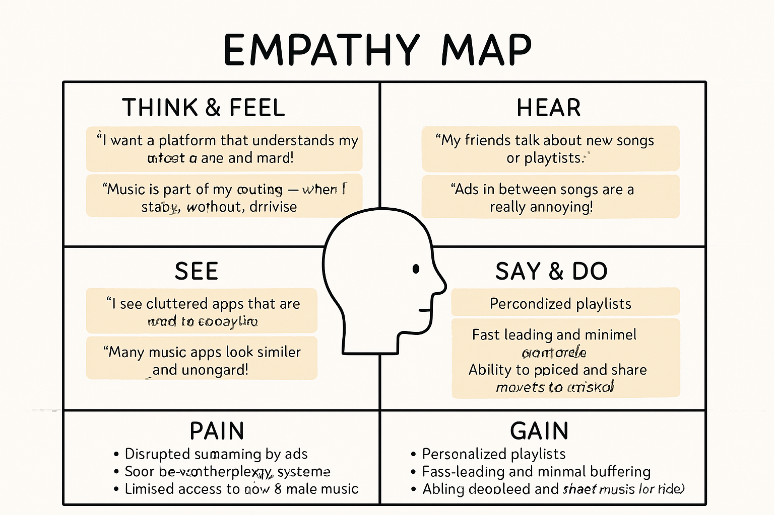

|  |  |  |
| --- | --- | --- |
|  |  |  |
| **Category** |  | **User Insights** |
| **Think & Feel** |  | “I want a platform that understands my music taste and mood.” “Music is part of my routine—when I study, workout, or relax.” |
| **Hear** |  | “My friends talk about new songs or playlists.” “Ads in between songs are really annoying.” |
| **See** |  | “I see cluttered apps that are hard to navigate.” “Many music apps look similar and unoriginal.” |
| **Say & Do** |  | “I usually search for specific songs or artists.” “I share music via links or social media.” |
| **Pain** |  | - Disrupted streaming by ads |

* Poor recommendation systems
* Limited access to new or indie music | | **Gain** | - Personalized playlists
* Fast loading and minimal buffering
* Ability to upload and share music (for artists) |

The empathy map helped us gain valuable insights into both listener and artist needs, influencing our feature planning and user experience design.

**2.3 Brainstorming**

Using collaborative brainstorming sessions and whiteboarding techniques, we generated various ideas to improve the overall user and artist experience. Here’s a summary of the key concepts discussed:

**Core Features**

* Music search with filters (genre, mood, artist)
* Playlist creation, editing, and sharing
* Recently played and favorite songs
* Personalized recommendations using listening history

**Artist Features**

* Upload music with metadata (album, genre, release date)
* Dashboard for stream analytics (plays, likes, shares)
* Option to publish singles or albums
* Monetization support via premium subscriptions

**User Interface Ideas**

* Dark/light mode switch
* Minimalist and responsive design
* Smooth transitions and animations
* Compact mobile player for multitasking

**Extended Ideas**

* Collaborative playlists between friends
* Lyrics display while listening
* Social feed showing what friends are listening to
* Voice search for hands-free interaction
* Event announcements for artist concerts or live sessions

After evaluating feasibility, value, and impact, we prioritized the most essential features for the MVP (Minimum Viable Product) version, ensuring that development could remain focused and user-centric.

**3. REQUIREMENT ANALYSIS**

**3.1 Customer Journey Map**

The **Customer Journey Map** illustrates the step-by-step experience of a user, from discovering the platform to becoming a regular listener or premium subscriber. It helps identify pain points, opportunities for engagement, and areas where the user experience can be improved.

|  | **Stage** | **User Action** | **User Thoughts/Needs** | **Touchpoints** |
| --- | --- | --- | --- | --- |
|  | **Discovery** | User hears about the platform via friends/social media | “Is this app worth trying? Is it better than Spotify or others?” | Social media, ads, word-of-mouth |
|  | **Onboarding** | User visits website and signs up/logs in | “How easy is it to get started?” | Landing page, login/sign-up page |
|  | **Exploration** | User browses genres, songs, or searches for favourites | “Can I find music I like quickly?” | Search bar, home page, recommendations |
|  | **Engagement** | Plays songs, creates playlists, likes tracks | “How do I organize my favourites? What’s new to listen to?” | Music player, playlist feature |
|  | **Conversion** | User tries premium subscription | “Is it worth paying for ad-free, high-quality music?” | Upgrade page, pricing plan, offers |
|  | **Retention** | Returns regularly, shares playlists, interacts with new music | “This feels like my personal music hub.” | Personalized recommendations, social features |

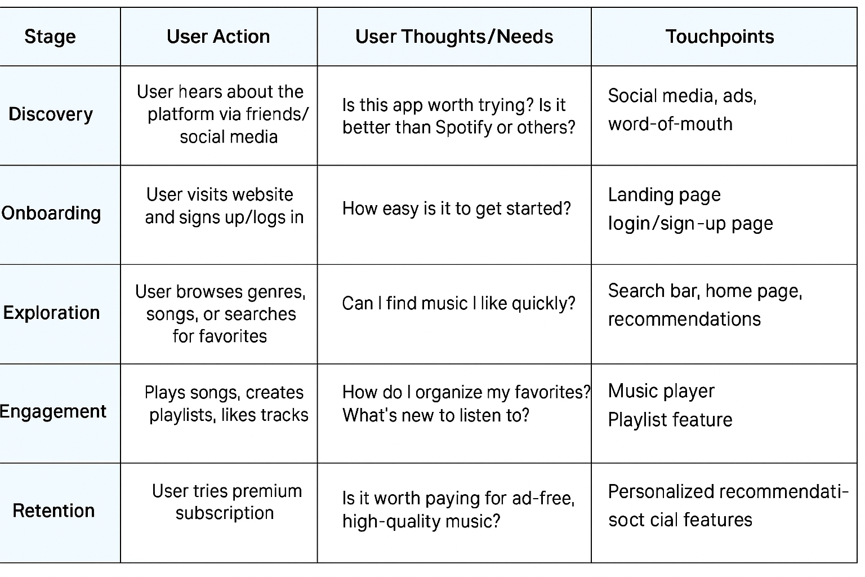

**3.2 Solution Requirements**

This section defines both **functional** and **non-functional** requirements for the music streaming platform.

**Functional Requirements**

* **User Registration/Login**: Secure account creation and login functionality.
* **Music Streaming**: Real-time streaming of music files with play/pause, skip, and shuffle features.
* **Search & Filter**: Keyword-based search for artists, albums, and songs.
* **Playlist Management**: Users can create, edit, delete, and share playlists.
* **User Profiles**: View listening history, liked songs, and personal preferences.
* **Artist Upload Portal**: Allow verified artists to upload songs, manage content, and view analytics.
* **Admin Panel**: For managing users, handling reported content, and moderating uploads.
* **Subscription Model**: Users can subscribe to a premium plan for extra features like ad-free and offline access.

**Non-Functional Requirements**

* **Scalability**: Should handle an increasing number of users and songs.
* **Security**: Authentication (JWT), password hashing, secure file access.
* **Availability**: High uptime using cloud services and CDNs.
* **Performance**: Fast load times and minimal buffering.
* **Cross-Platform**: Fully responsive design for desktop and mobile.

**3.3 Data Flow Diagram (DFD)**

**Level 0**

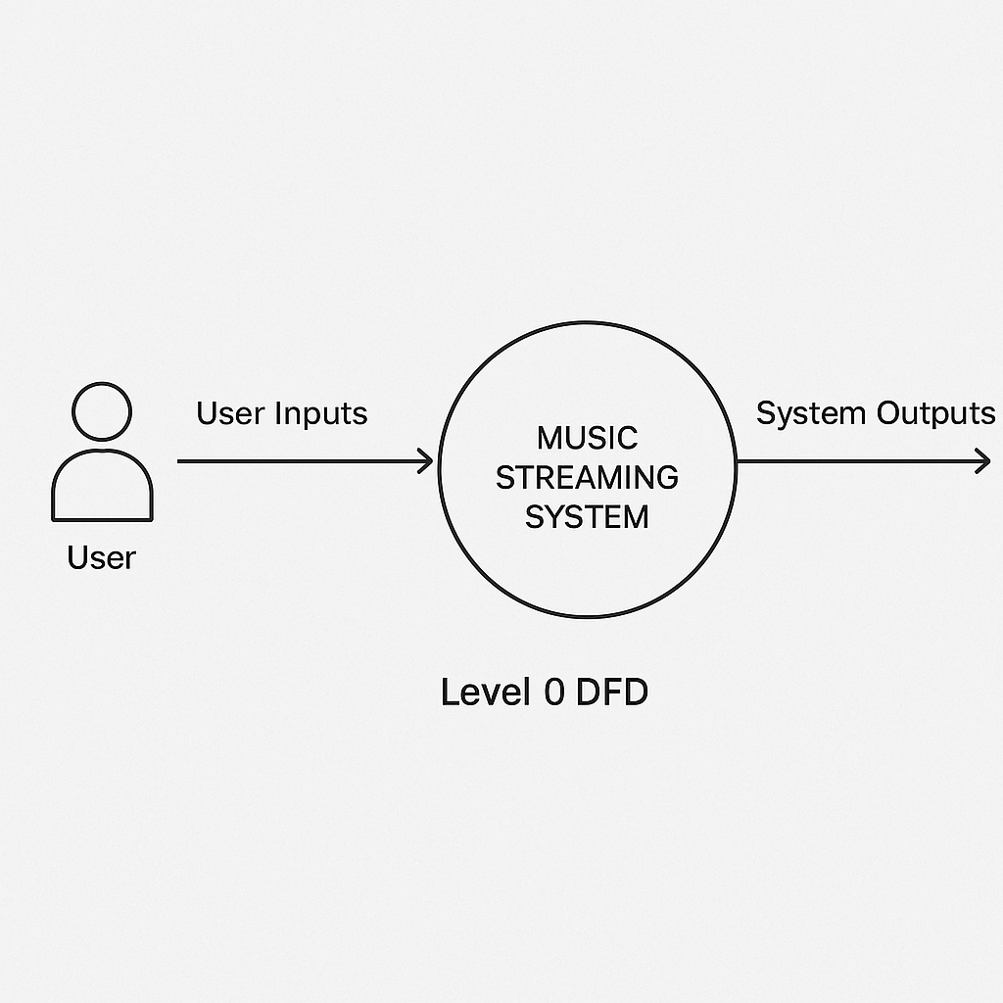

**LEVEL 1**

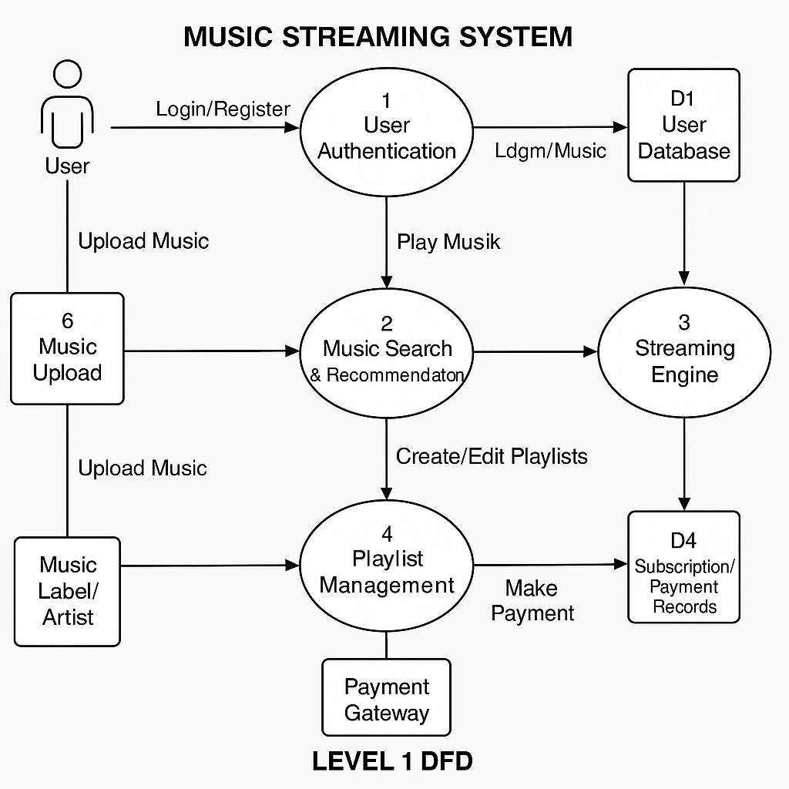

**3.4 Technology Stack**

Here’s the chosen technology stack categorized by the development layer:

**Frontend**

* React.js: Component-based UI development
* Tailwind CSS: Fast, utility-first styling
* Axios: For handling HTTP requests

**Backend**

* Node.js: Runtime environment
* Express.js: RESTful API development
* JWT (JSON Web Token): For user authentication
* Bcrypt.js: For secure password hashing

**Database**

* MongoDB (Atlas): NoSQL document-based storage
  + Collections: Users, Songs, Playlists, Subscriptions, Artists

**Cloud & Storage**

* Firebase Storage or AWS S3: For storing music files and album art
* Cloudinary: Optional, for handling media transformations

**Deployment**

* Vercel / Netlify: For deploying frontend
* Render / Railway: For backend and server hosting

**Testing Tools**

* Postman: For API testing
* Jest & React Testing Library: For frontend unit testing

**Analytics & Monitoring**

* Google Analytics: User activity monitoring
* MongoDB Charts / Custom Dashboards: For artist stats and admin insights

**4. PROJECT DESIGN**

4.1 Problem-Solution Fit

The Problem-Solution Fit is the alignment between a real-world problem faced by users and the solution our platform offers.

**Problem Recap**

* Users face difficulty in discovering new music tailored to their taste.
* Independent artists lack platforms that give visibility and monetization without intermediaries.
* Popular streaming services are overloaded with features, but not always intuitive.
* Excessive ads and lack of offline modes irritate free-tier users.

**Our Solution**

We propose a streamlined music streaming platform that:

* Offers personalized music recommendations based on listening history and mood.
* Provides independent artists with tools to upload, manage, and monetize their content.
* Maintains a clean, minimal UI/UX for all types of users (tech-savvy or not).
* Introduces freemium and premium tiers, with ad-free listening and downloads for premium users.

This ensures a fit between the actual user needs and our product’s core features.

**4.2 Proposed Solution**

Our proposed solution is a full-stack web-based music streaming platform that serves both listeners and artists, focusing on personalization, simplicity, and inclusivity.

**Key Features**

* User Panel:
  + Browse and stream music by genre, mood, or artist.
  + Create and manage playlists.
  + Like, comment on, and share songs.
  + Personalized homepage and recommendation engine.
* Artist Panel:
  + Upload music tracks, set genre/tags, manage albums.
  + Track performance (views, likes, followers).
  + Monetization through subscription engagement or donations.
* Admin Panel:
  + Approve artist accounts and manage flagged content.
  + Oversee analytics of user activity and content trends.
* Tech Features:
  + Smooth streaming with buffered preloading
  + Scalable backend with RESTful APIs
  + JWT-based secure authentication
  + Responsive UI across desktop and mobile

**4.3 Solution Architecture**

Below is a high-level overview of the architecture of the system: 1. Client Layer (Frontend)

* React.js based SPA (Single Page Application)
* Axios for communicating with backend APIs
* Tailwind CSS for styling
* Features:
  + User interaction interface
  + Dynamic playlist UI
  + Real-time music control bar

2. Server Layer (Backend)

* Node.js + Express.js server
* Handles API routing, authentication, file processing
* Uses Multer middleware for file uploads
* Implements JWT for secure session handling

3. Business Logic Layer

* Recommendation algorithm (based on tags, genres, likes)
* Role-based access (admin, artist, listener)
* Song access control (free vs. premium)

4. Database Layer

* MongoDB (Atlas) – for storing:
  + User profiles
  + Song metadata (name, artist, duration, genre)
  + Playlists
  + Analytics logs
* Indexed fields for fast querying
* Relationships handled through ObjectId referencing

5. Storage & Delivery Layer

* Cloudinary / Firebase Storage / AWS S3 for:
  + Hosting audio files and cover art
* CDN Integration for faster access globally

6. Authentication & Security

* JWT tokens for login sessions
* Bcrypt for password hashing
* Input validation to prevent injection attacks

7. Analytics & Monitoring

* Admin dashboards for song popularity
* Artist dashboard for individual song performance
* Google Analytics / Mixpanel for tracking engagement

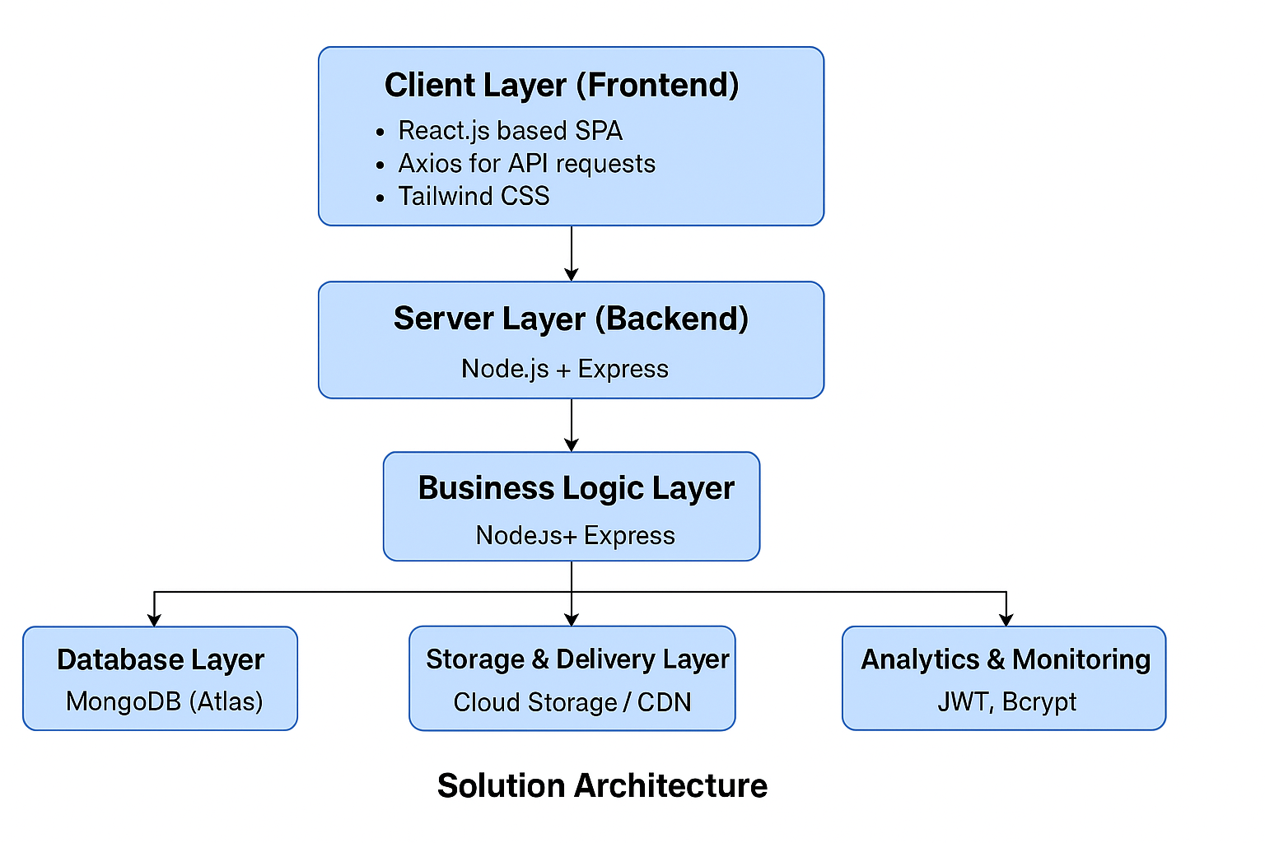

**5. PROJECT PLANNING & SCHEDULING**

**5.1 Project Planning**

The development of the Music Streaming Website is planned over distinct phases to ensure efficient resource utilization, timely delivery, and proper testing. The project follows an agile methodology with iterative development and continuous integration.

**Phases of Development:**

1. Requirement Analysis
   * Identifying core features for users and artists
   * Defining tech stack (MERN, JWT, cloud storage)
2. UI/UX Design
   * Creating wireframes and mockups
   * Designing responsive layouts for desktop and mobile
3. Backend Development
   * Setting up MongoDB schema and Express.js APIs
   * Implementing user authentication using JWT
   * Handling file uploads with cloud integration (e.g., Cloudinary or AWS S3)
4. Frontend Development
   * Developing React components for music browsing, playlist, user profile
   * Integration of media player and streaming functionality
   * Implementing Redux or Context API for state management
5. Testing & Debugging
   * Unit testing for API endpoints
   * Frontend component testing
   * Manual testing for UI/UX and music playback
6. Deployment & Hosting
   * Hosting frontend and backend (e.g., Vercel/Netlify + Render/Heroku)
   * Connecting domain and SSL configuration
7. Maintenance & Feedback Integration
   * Regular updates based on user feedback
   * Performance optimization and bug fixes

**Estimated Timeline:**

| Phase | Duration | Status |
| --- | --- | --- |
| Requirement Analysis | Week 1 | Completed |
| UI/UX Design | Week 2 | Completed |
| Backend Development | Week 3–4 | Completed |
| Frontend Development | Week 4–5 | Completed |
| Testing & Debugging | Week 6 | Completed |
| Deployment | Week 7 | In Progress |
| Feedback & Maintenance | Week 8+ | In Progress |

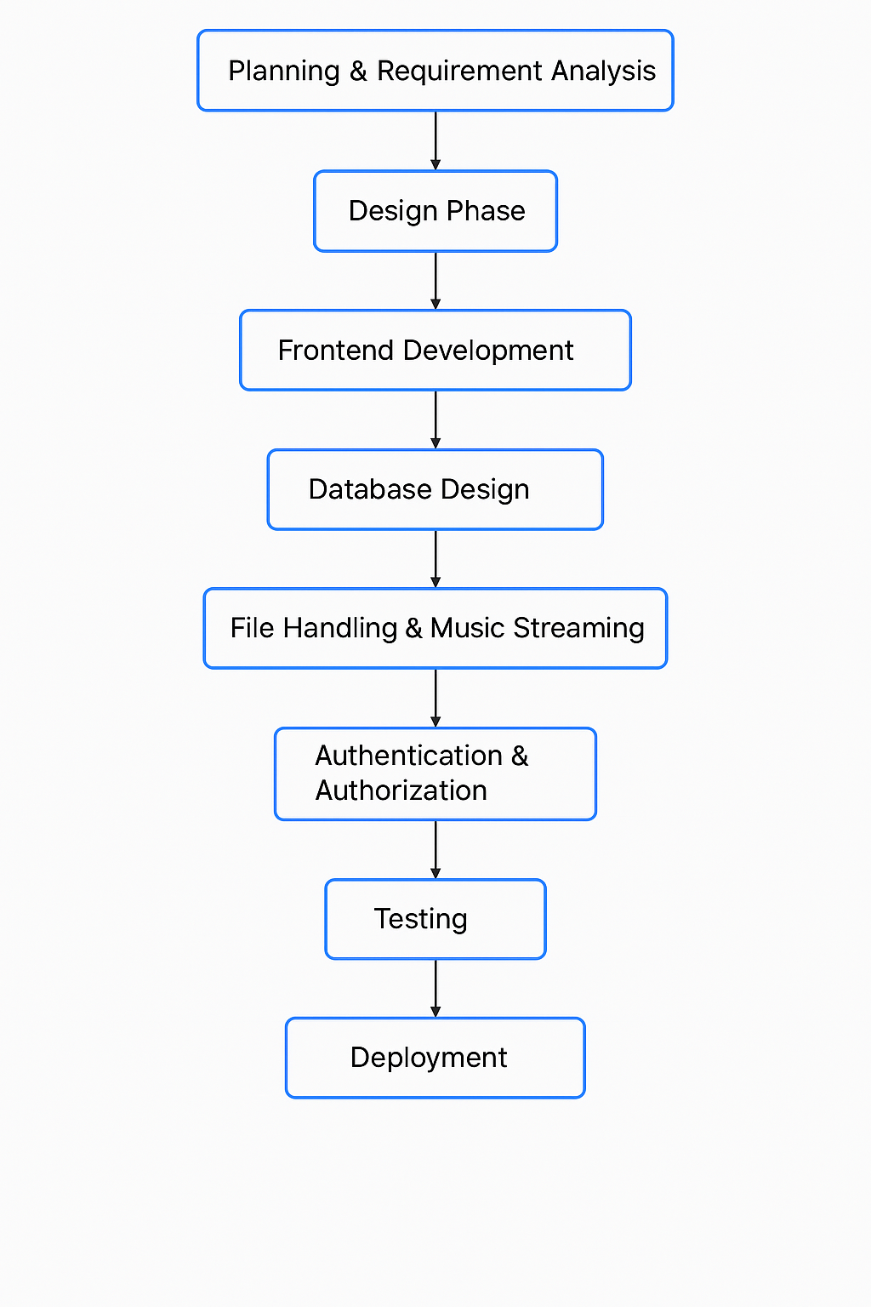

**6. FUNCTIONAL AND PERFORMANCE TESTING**

**6.1 Performance Testing**

Performance testing ensures that the application is fast, reliable, scalable, and can handle various real-world conditions across frontend and backend systems. The key objectives and elements of performance testing are detailed below:

**Objectives of Performance Testing**

* Ensure Fast and Reliable Streaming  
  Test stream start times (≤ 2s), buffering frequency (≤ 1 per 10 min), and playback stutter.
* Handle Concurrent Users and Actions  
  Simulate scenarios like:
  + 1000 users logging in simultaneously
  + 500 users searching
  + 800 users streaming
  + 200 creating playlists
  + 1000 using recommendations
* Backend/API Performance
  + API response time ≤ 200 ms
  + Use tools like JMeter, k6, and Postman to measure and optimize endpoints.
* Database Performance
  + Query time ≤ 300 ms under heavy load.
  + Optimize with indexing, caching (Redis), and query tuning.
* Frontend and Mobile Responsiveness
  + Page load time ≤ 1 second
  + Test across devices and simulate 3G/4G/5G using Chrome DevTools, Lighthouse, etc.
* Resource Usage and Stability
  + CPU/Memory ≤ 80% under peak load
  + Uptime ≥ 99.9%
  + Monitor using Prometheus, Grafana, AWS CloudWatch.
* Scalability and Fault Tolerance
  + Test system scaling with users and content growth.
  + Use Kubernetes, Docker, PM2 for load balancing and scaling.

**Types of Performance Testing**

| Type | Description | Example |
| --- | --- | --- |
| Load Testing | Normal load capacity | 500 users streaming simultaneously |
| Stress Testing | Beyond normal limits | 10,000 users or mass uploads |
| Soak Testing | Long-duration performance | 100 users streaming for 12 hours |
| Spike Testing | Sudden increase/decrease in load | Viral content spike |
| Scalability Testing | System's ability to grow with increased resources | Adding DB nodes and servers |
| Volume Testing | Large data processing | Millions of tracks/playlists |
| Latency Testing | Delay between request and response | Stream start delay |
| Concurrent Testing | Diverse simultaneous user actions | Streaming, searching, uploading together |

**Key Performance Metrics**

| Metric | Ideal Target |
| --- | --- |
| API Response Time | ≤ 200 ms |
| Stream Start Time | ≤ 2 seconds |
| Page Load Time | ≤ 1 second |
| Uptime | ≥ 99.9% |
| Concurrent Users Supported | ≥ 1000 |
| Buffering Frequency | ≤ 1 per 10 min |
| DB Query Time | ≤ 300 ms |
| CPU/Memory Usage | ≤ 80% |
| Error Rate | < 1% |

**Performance Testing Tools**

| Area | Tools |
| --- | --- |
| Backend Load Testing | JMeter, k6, Artillery |
| API Performance | Postman, Insomnia, k6 |
| Frontend Performance | Google Lighthouse, Chrome DevTools, WebPageTest |
| Monitoring/Logging | Prometheus, Grafana, New Relic, ELK Stack |
| Cloud Performance | AWS CloudWatch, Azure Monitor |
| CI/CD Integration | Jenkins, GitHub Actions with testing plugins |

**Test Scenarios**

* API Load Scenarios:  
  1000 users login, 500 search concurrently, 800 stream simultaneously.
* Streaming Scenarios:  
  Measure stream start delay, playback for 10+ minutes, actions like pause/resume/seek.
* Upload/Admin Scenarios:  
  Artists uploading 10+ tracks, loading analytics dashboard with heavy data.
* Playlist/User Behavior:  
  200 users saving playlists, 1000 accessing recommended songs.
* Mobile/Device Testing:  
  Varying screen resolutions and network throttling for mobile performance.

**Test Reporting and Analysis**

* Monitor trends in response times (min, max, avg)
* Analyze error types (timeouts, 500s)
* Track CPU/memory/network graphs
* Simulate user behaviors and assess outcomes
* Pinpoint bottlenecks in APIs, DB queries
* Provide actionable recommendations for improvements

**7. RESULTS**

**7.1 Output Screenshots**

Below are some key output screens captured from the developed platform:

1. **Landing Page**
   * Welcome screen with login/signup options

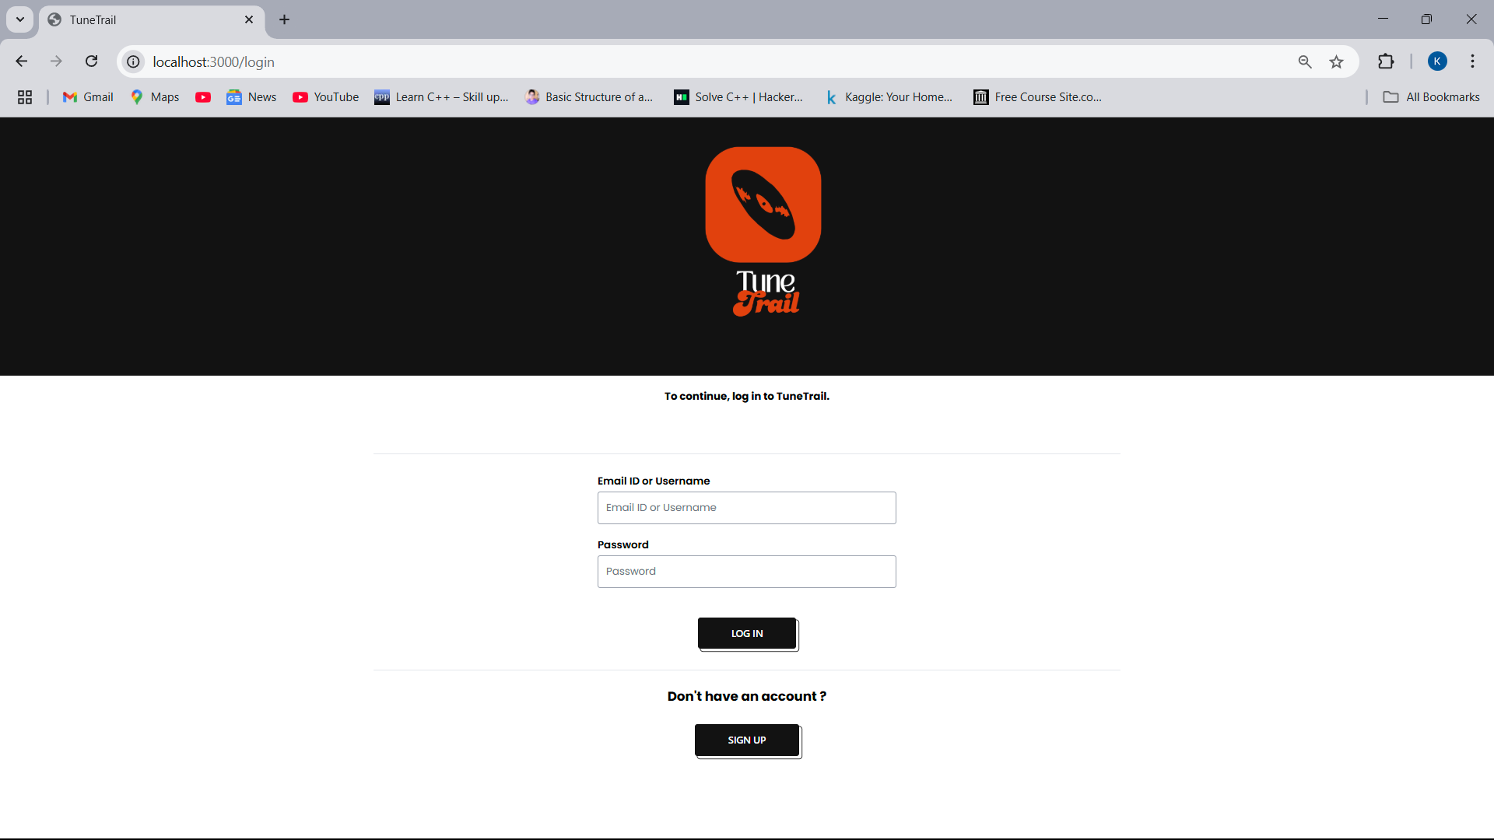

1. **User Dashboard**
   * Song library browsing

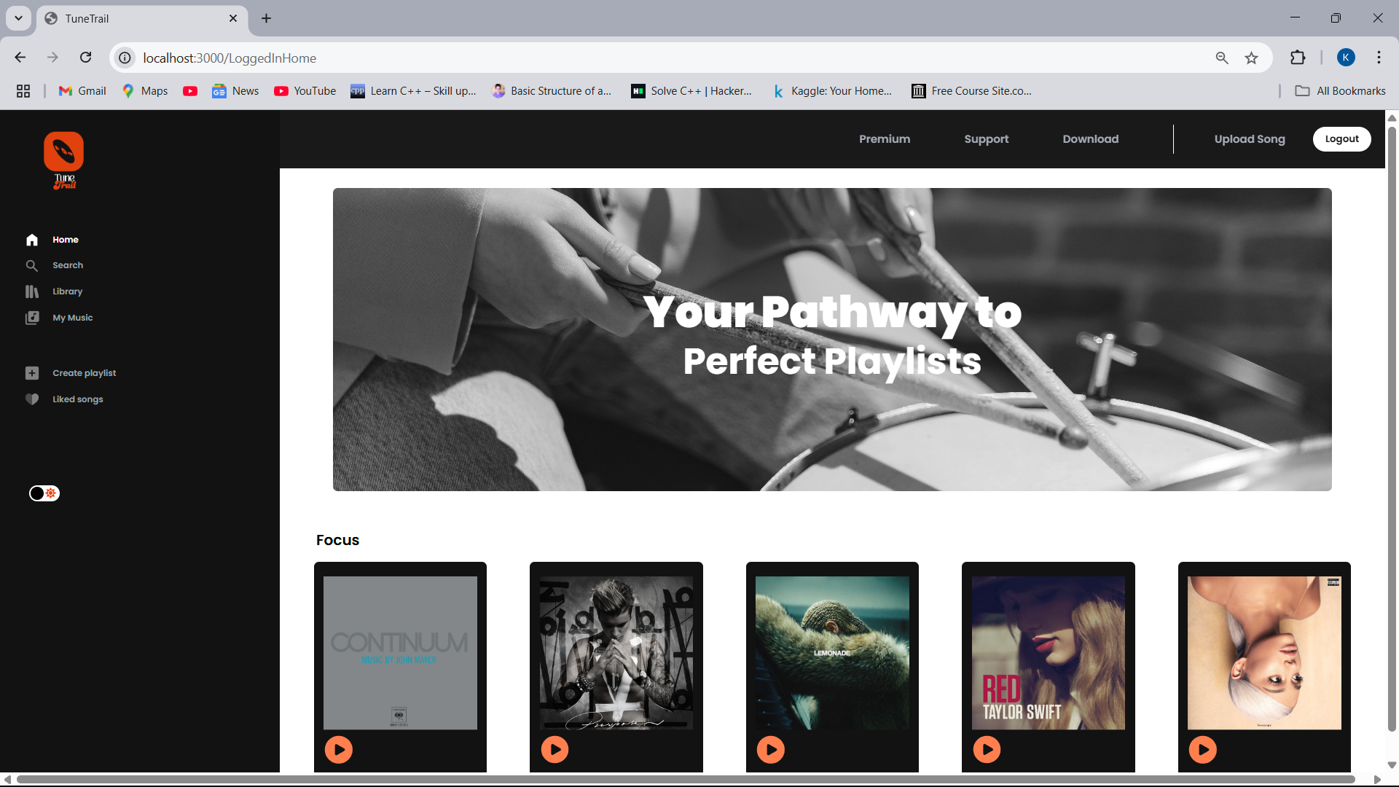

1. **Artist/Admin Panel**
   * Upload new songs
   * View play analytics and manage uploaded content

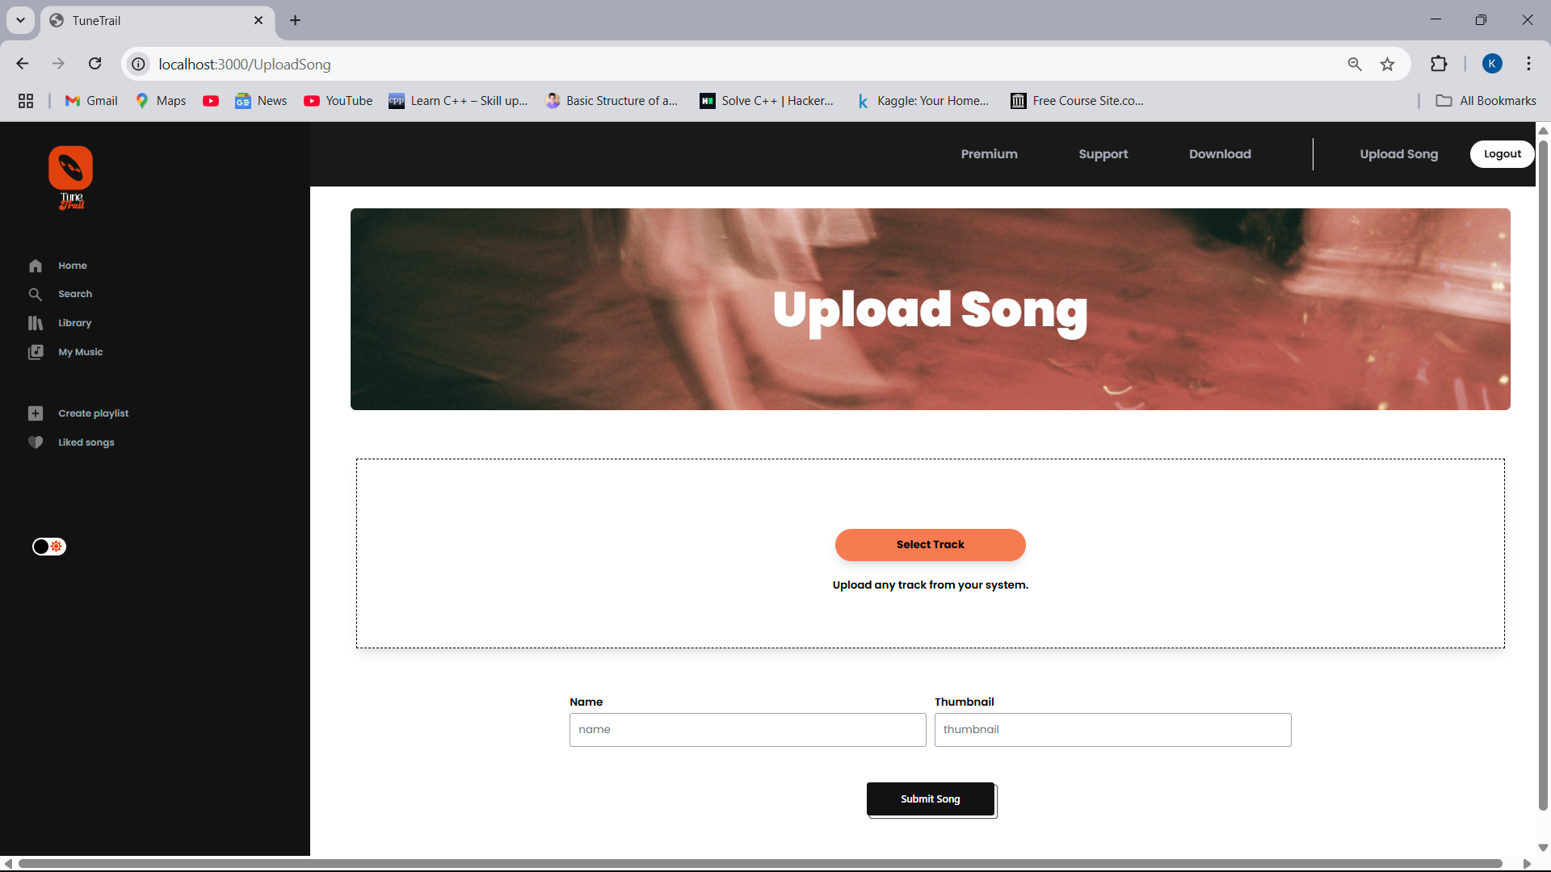

1. **Create Playlist**

* Create playlist of your choice

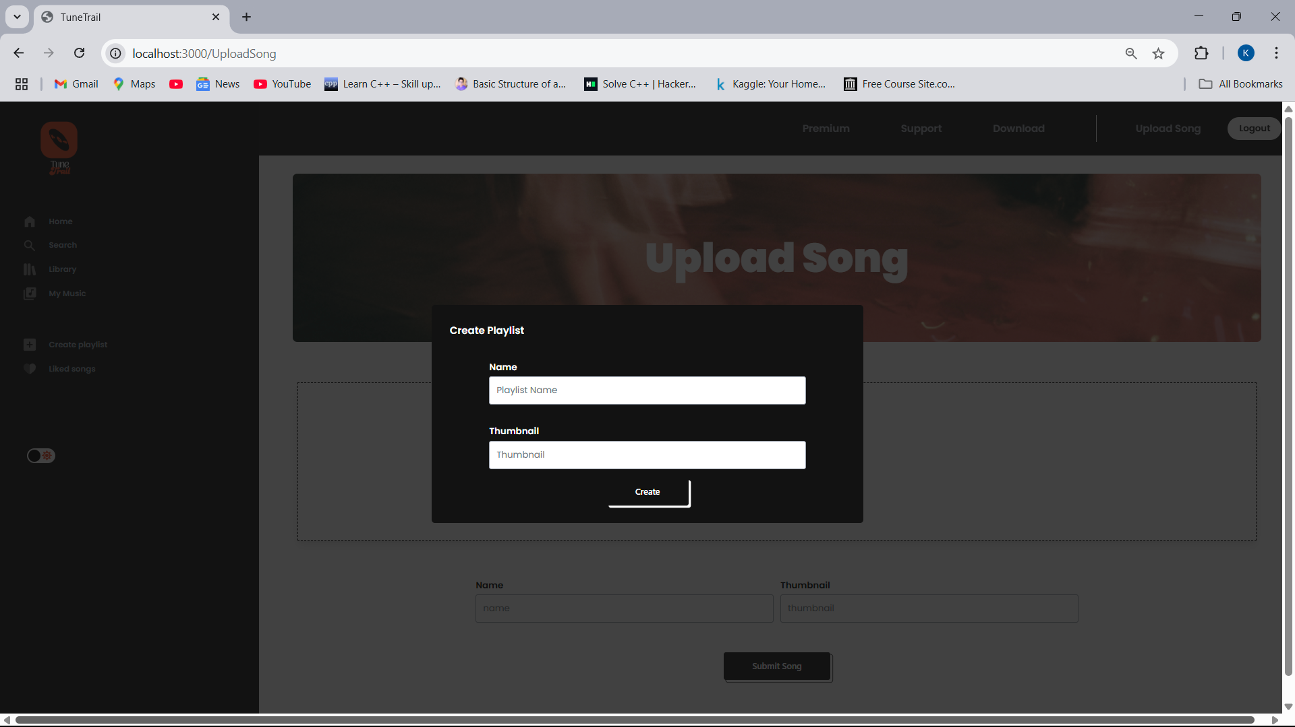

1. **Music Player UI**
   * Play, pause, seek bar, volume control, and queue

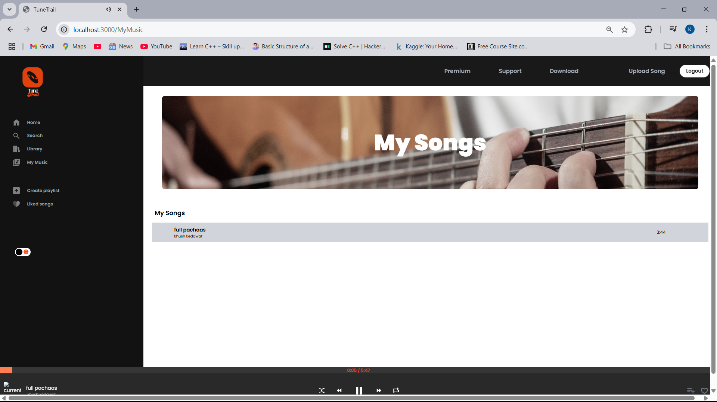

**8. ADVANTAGES & DISADVANTAGES**

**Advantages**

* Seamless User Experience: Clean UI with smooth streaming and intuitive navigation.
* Personalized Recommendations: Tailored suggestions using listening data.
* Support for Independent Artists: Artists can publish and monitor performance.
* Cross-Platform Compatibility: Responsive design for all screen sizes.
* Freemium Model: Monetization through subscriptions without limiting access.

**Disadvantages**

* High Initial Hosting Cost: Cloud storage and streaming require substantial resources.
* Content Licensing: Legal challenges if hosting third-party music.
* Data Privacy Risks: Need for strong measures to secure user data.
* Dependency on Internet: Offline mode limited to premium users.
* Complexity in Real-Time Features: Live streaming and syncing require advanced optimization.

**9. CONCLUSION**

The creation of this music streaming website marks a significant step toward building a dynamic and interactive platform for audio entertainment. By combining intuitive design with robust backend functionality, the project successfully delivers a user-centric experience where individuals can discover, stream, and enjoy music anytime and from any device.

This project has demonstrated the practical application of several core concepts in web development, including responsive UI design using modern frameworks (e.g., React.js or Vue.js), secure user authentication, seamless media streaming, and real-time interactivity. Through features like curated playlists, artist and track search, and personalized libraries, the platform emphasizes user engagement and accessibility.

From a development perspective, this website not only reflects technical proficiency but also showcases thoughtful planning, modular coding practices, and scalability considerations. It serves as a foundation for building more advanced music-related services in the future, proving the feasibility of creating entertainment platforms even with limited resources.

Moreover, the project reinforces the importance of understanding user needs, performance optimization, and responsive design. Whether accessed via desktop or mobile, the platform aims to maintain a consistent and smooth user experience, which is vital in today’s digital landscape.

In conclusion, the project has met its primary goal: to offer a functional, aesthetically pleasing, and responsive music streaming platform. It sets the stage for future innovations, including AI-driven music recommendations, mobile app deployment, and social integration — all of which could transform it from a personal project into a full-fledged digital product.

**10. FUTURE SCOPE**

* Mobile App Integration: Expanding the service into Android and iOS apps to enhance portability and access.
* AI-Powered Recommendations: Implementing machine learning algorithms for personalized music suggestions based on user behavior and listening patterns.
* Offline Mode: Allowing users to download tracks and play them without internet connectivity.
* Live Streaming: Integrating live concert streams or artist sessions to increase engagement.
* Social Features: Adding features like sharing playlists, commenting, and following friends to make the platform more community-driven.
* Monetization Models: Introducing premium plans, ad support, or artist donations to sustain and grow the platform.

**11. APPENDIX**

Source Code (if any)

[GitHub Repository](https://github.com/yourusername/music-streaming-website)

GitHub & Project Demo Link

* GitHub: <https://github.com/yourusername/music-streaming-website>
* Live Demo: